PCL5 Printer Driver User Instructions

When printing from an application, there is an opportunity to change your printer preferences. You can change these preferences by selecting a button labeled Properties, Preferences, or Options. The following pages will explain the options you’ll find in the printer preferences window for PCL5e drivers.

- The first thing you’ll need to do is reach the printer preferences window. There are a couple ways to do this. The first is to print from an application such as Microsoft Word, Microsoft Excel, or Paint for example. The following pictures highlight where to look for the preferences button in these programs.

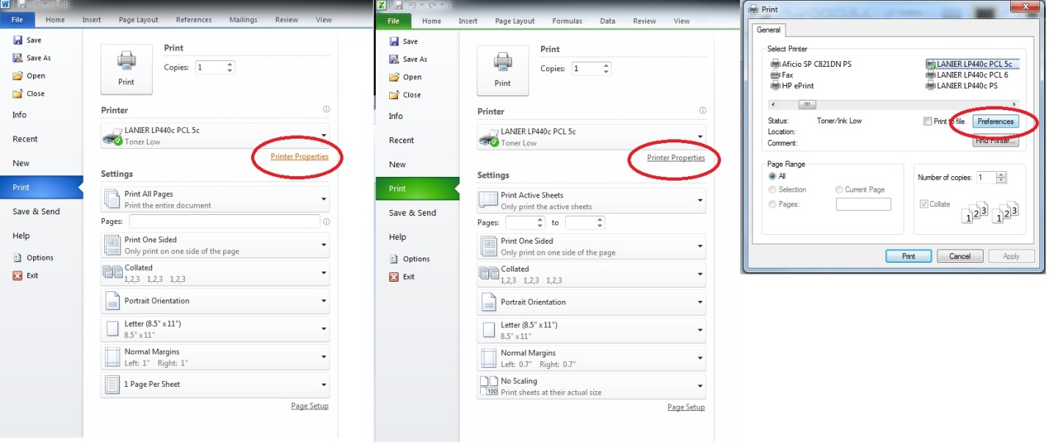

Alternatively, you can pull up the preferences for any printer by going to your Start Menu and selecting Devices and Printers and then right clicking your printer and clicking on Printing Preferences.

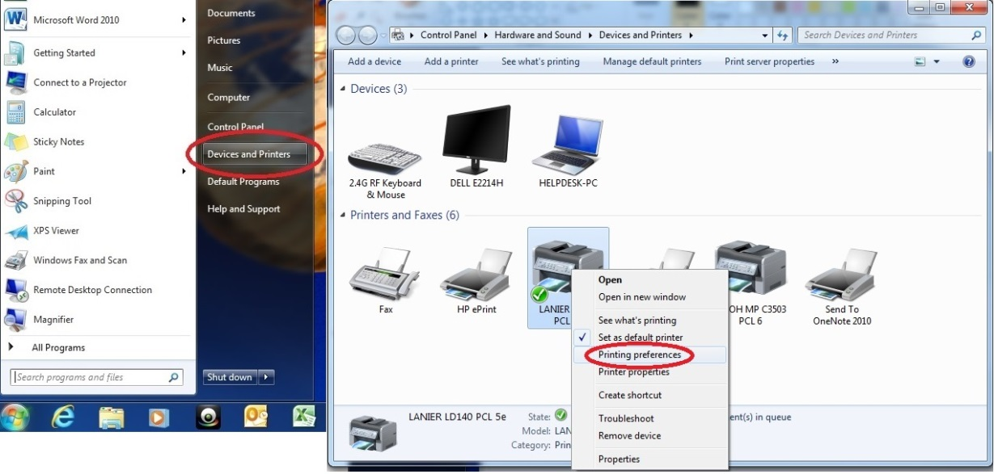

- Your Printer Preferences should then come up on the Setup tab. There are a few things to note about this tab. There is a graphic of a page in the top left corner. Whenever you change a setting this graphic will change to represent your new setting. In addition, an overview of your current settings will display below this picture. If you need to save these settings. You can use the Save button below your settings overview. Use the Load button to load saved preferences. The Job Type menu will be covered in the next step. On this screen you can also set your Orientation, Layout, Page Order, Color/Black and White option (Color only available on Color machines), and Front/Back printing, also known as Duplex. If your Multifunctional (MFP) has a finisher this is where the Sorting and Stapling options are set (See Note on next page). Each one of these options will have graphics that will change as you pick your settings.

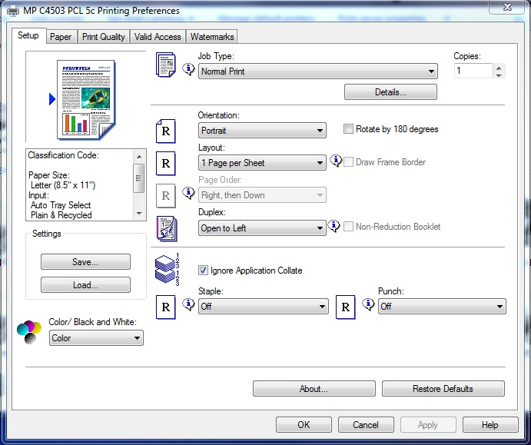

Note: For finisher options make sure you have gone to the Printing Properties option for your printer from the Devices and Printers window. (See Step 1) Once into this window click the Accessories tab, see that all your finishers/trays are checked, and then click the Update Now button at the bottom.

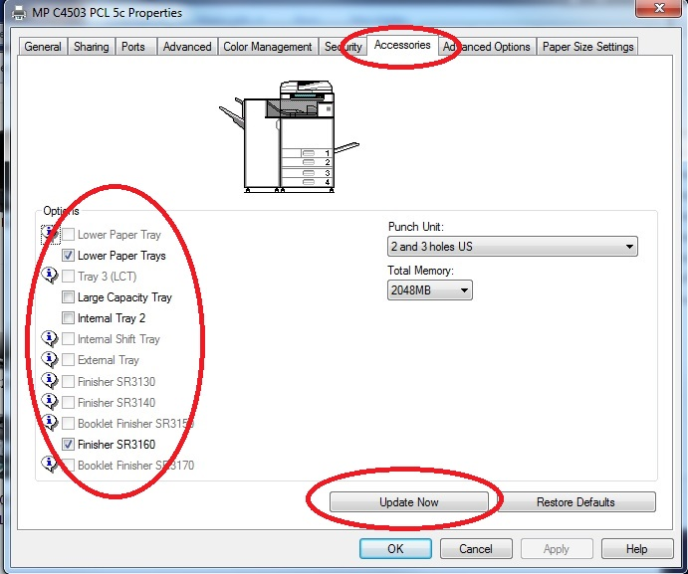

- Next let’s look at the different job types a printer can accommodate.
- The first option is Normal Print. This option is the default job type, where when you click print on the computer your job is sent to the printer and prints during the next available time.
- The next option is Sample Print. This job prints only the first copy of many copies so the user can look over the document and make sure it’s the way it is supposed to be. The user then can continue to print the rest of the copies or reset the job.
- The third option is Locked Print. This job type makes the user input a User ID and Code under the Details option. The user would then go to the printer, look up their job and User ID and input their Code, and then the printer will print their job.
- The next option is Hold Print. This option works similar to Locked Print, however a user doesn’t have to put in a Code.
- Stored Print is the next option. Stored Print is an option where you can store an electronic copy of a document on the printer job list to print later from the printer control panel. User ID/Code is required to print this job. Set these up under the Details button.
- Another option is Store and Print. This job type allows a user to send an electronic copy of a document to the printer to print and also stores a copy on the printer job list for a later print job. User ID/Code is required to print this job. Set these up under the Details button.
- The final job type is Document Server. This job allows you to save an electronic copy of a document on the printer for later multiple uses. This is a handy function for forms that are repeatedly used by a company. User ID/Code/Folder Password can all be set up in the Details button; however the only required info is the file name.

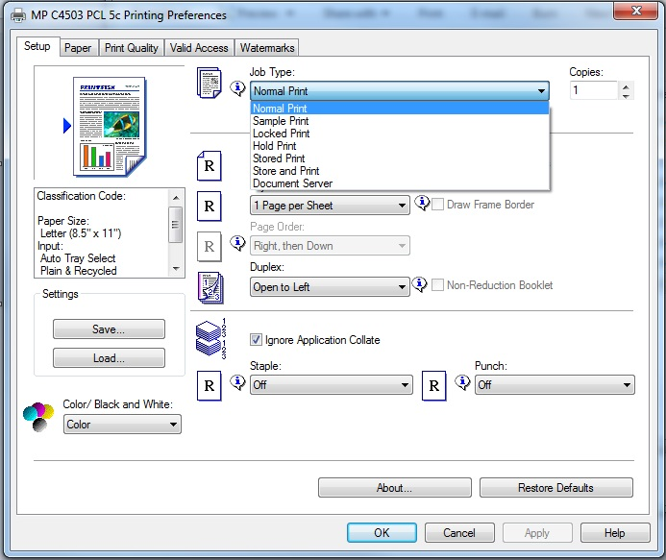

- Next pull up the Paper tab on the top menu. On this tab you can change your Document size, as well as select the type and size of paper the printer will use. The Type selection is where the paper type is set such as glossy, thick, plain, cardstock, etc. Being specific here can improve the quality of your job and reduce the chance of misfeeds. The Input Tray menu is where you can select which tray you want the MFP to pull from. Different types of paper can be in each tray, and paper stocks don’t need to be changed on a per job basis. Make sure you know what types of paper you have in each tray on your MFP. Once again pay attention to the paper stack graphic and the printer graphic. These will change as you change settings to provide a better understanding of how these options affect your print job.

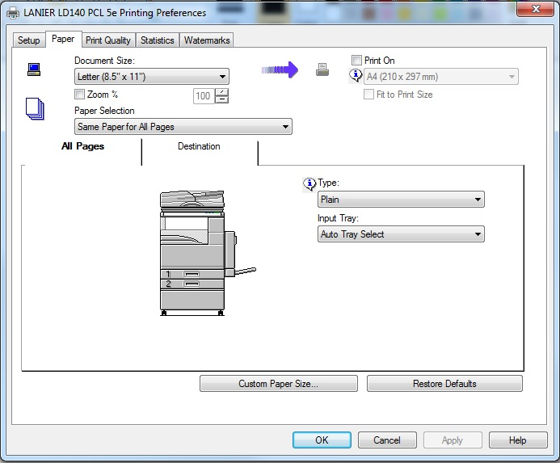

- The third tab at the top is Print Quality. In this menu you can change resolution and other graphics. For color MFP’s color management options can be accessed by clicking the Manual check box and then clicking the Advanced button. Increasing to a higher resolution will make for a better image quality but will use more toner. Tailor this setting to your specific environment. Also be sure to check to see whether your jobs need the Edge Smoothing or Toner Saving options.

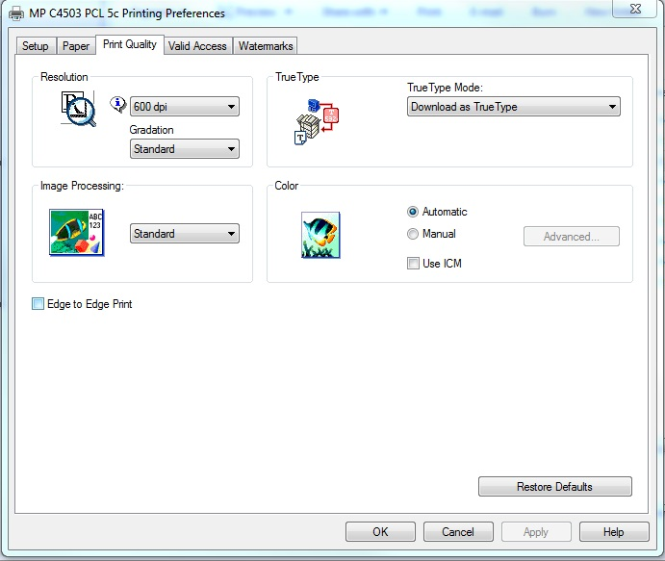

- The Statistics or Valid Access tabs are where you can input your user code for print jobs that require authentication. This option is useful in environments that need to limit MFP use and abuse.

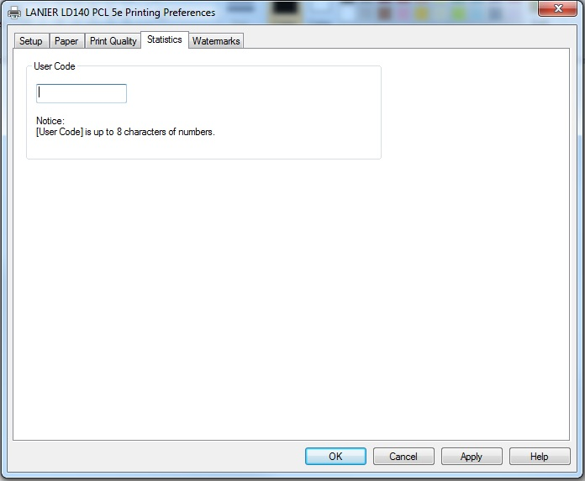

- The final tab at the top is Watermarks. In this tab you can add and format watermarks for your print job. This is useful to discourage unauthorized copying of documents. Watermarks can be selected from the default list which includes: Confidential, Urgent, Draft, Original, or Copy. Or users can add their own text and adjust size, angle, centering, color, and even font of their watermark.

